STRATEGIC ANALYSIS OF TELECOM CUSTOMER CHURN
TABLE OF CONTENTS
1. OVERVIEW 3
2. DATA METHODOLOGY & PREPARATION 4
3. TARGET VARIABLE ANALYSIS 5
4. DEMOGRAPHIC ANALYSIS 6
5. SERVICE ANALYSIS 7
6. FINANCIAL ANALYSIS 8
7. ROOT CAUSE ANALYSIS 9
8. CONCLUSION 10

OVERVIEW
In the telecommunications sector, the cost of getting a new customer is outweighs the cost of retaining an existing customers. High churn rates reduce the profit and market share. In this project, Python is used to analyse the data and visualize it and get the reason behind the customer churn in the business
Data Sets
The dataset used for this analysis contains 7,043 rows (representing individual customers) and 21 columns (representing their attributes).
The dataset have below set of information
- Demographic Information
- Services Subscribed
- Account & Financial Information
Tech Stack
Language: Python
Libraries:
- Pandas (Data Wrangling)
- Matplotlib/Seaborn (Visualization)

DATA METHODOLOGY & PREPARATION
The analysis is based on two datasets: Customer Data and Zip Code Population Data.Both data sets joined and created the master data set for better analysis
Before we deep dive into analysis, need to cleanup the data and crosschecks the data quality
- Data Integration
- Handling Missing Values
- Duplicate checking
Feature Engineering: There is new column called “Age group” was added based on the customer age and divided into three groups (Young, Adult and Senior)
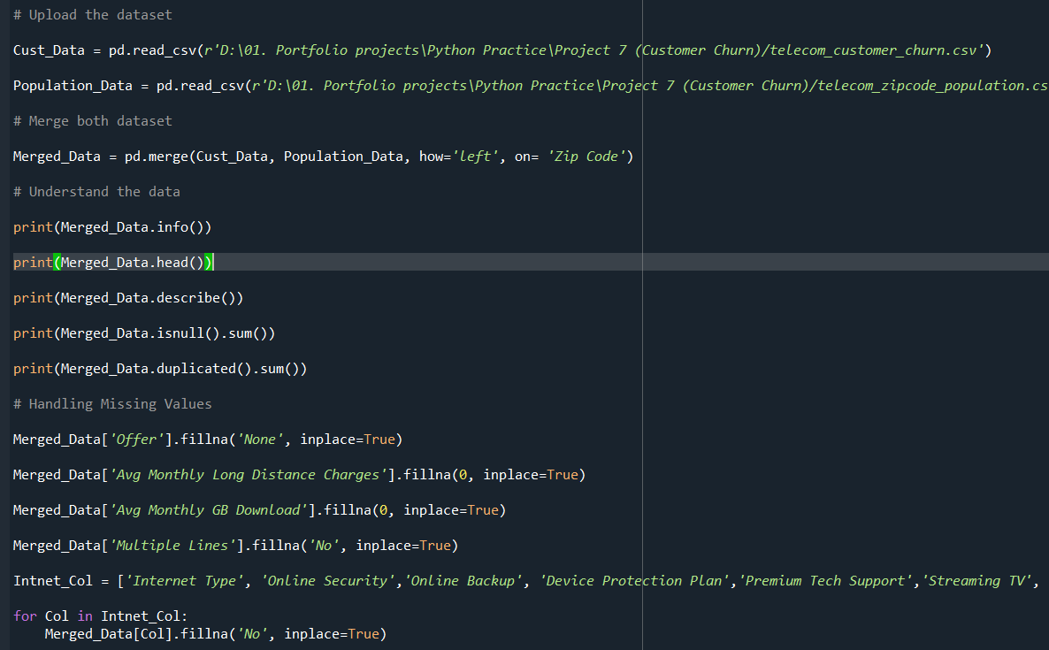

TARGET VARIABLE ANALYSIS
Overall Churn rate is our target variable. Its shows where are at the moment of customer retention The data was grouped based on the customer status (churned stayed, joined)
1,869 out of 7,043 customers have left the company. The churn rate is 26.5%.
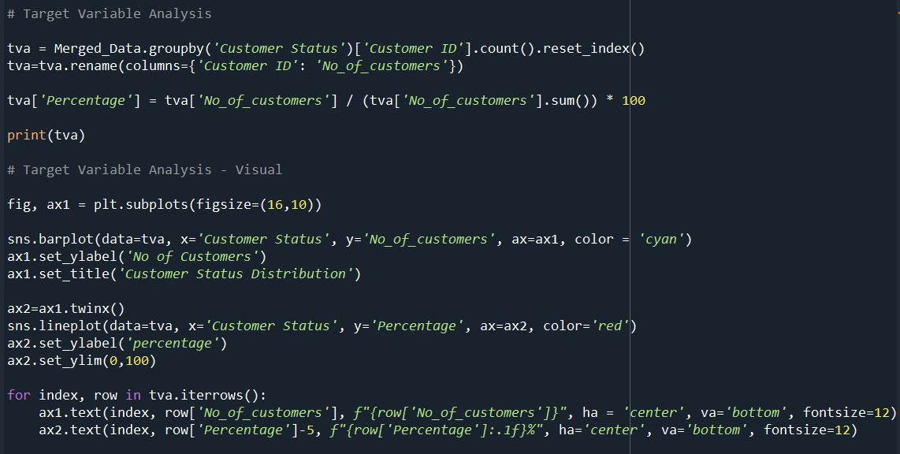
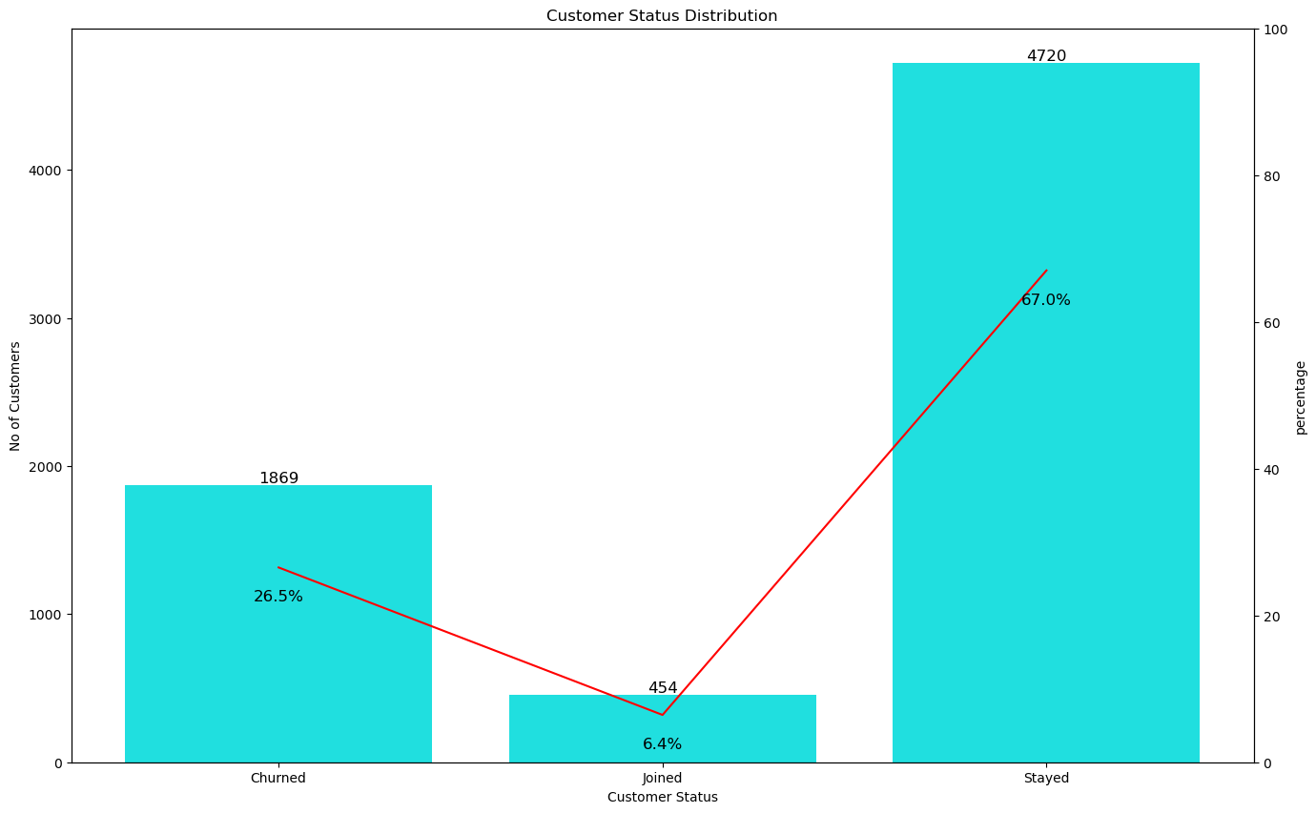

DEMOGRAPHIC ANALYSIS
Customers divided into three different age groups (Young, Adult, and Senior) using pd.cut Churn rate was calculated based on the group and 36.5% of senior customers was discontinued
This tells we need focus on giving better service for senior customers interms of offers and support
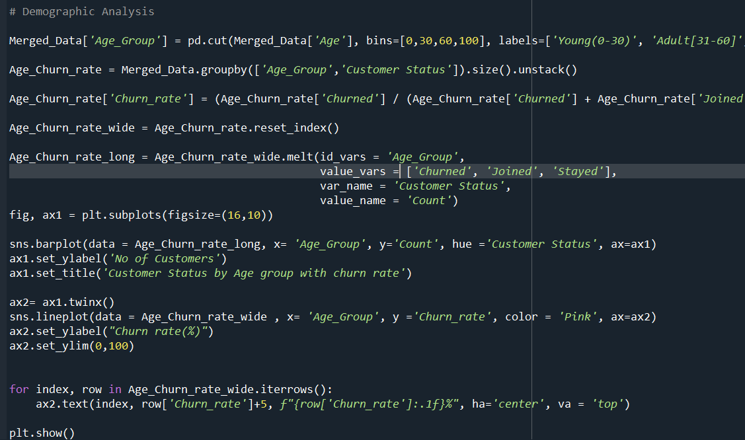
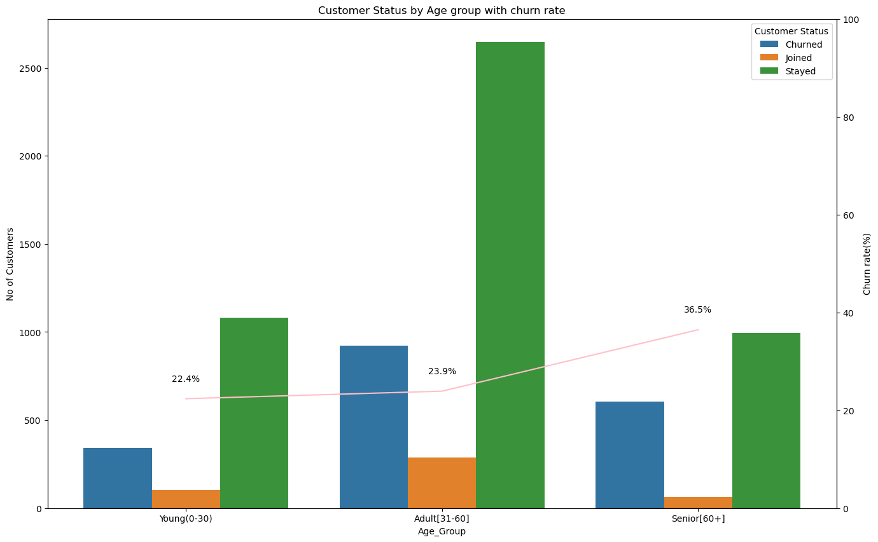

SERVICE ANALYSIS
We did two different analysis based on service.
- Internet type(cable, DSL, or fiber option
- Contract analysis(monthly, one year and two year)
Fiber Optic has an unexpectedly high churn rate of 40.7%, compared to DSL at 18.5%.
Month-to-Month contracts experience massive churn (45.8%)
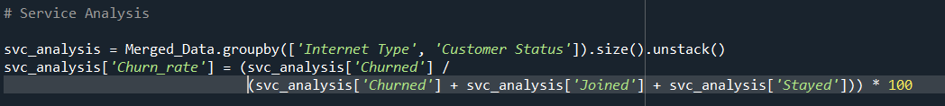
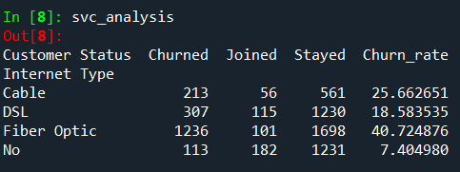

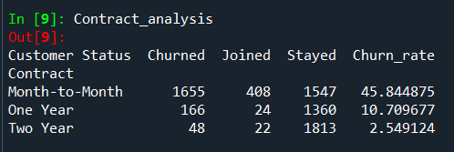

FINANCIAL ANALYSIS
In the financial analysis, we have analysed the customer chur rate based on monthly charges.
We have used histogram to see how the distribution between the monthly charges
- Average bill for a retained customer: $61.73
- Average bill for a churned customer: $73.34
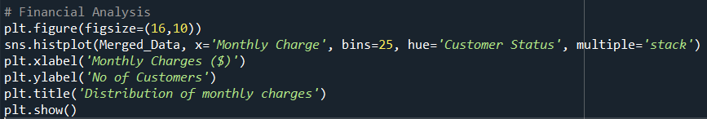

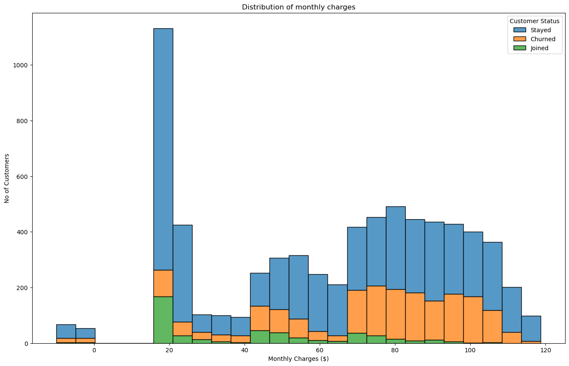

ROOT CAUSE ANALYSIS
We have analysed the reasons root Cause for 1,869 churned customers, We able see the top reasons for why customer discontinued
- Better devices (16.7%) ,better offers (16.6%) and Attitude of support person (11.8%) are the top three reasons for leaving from our service
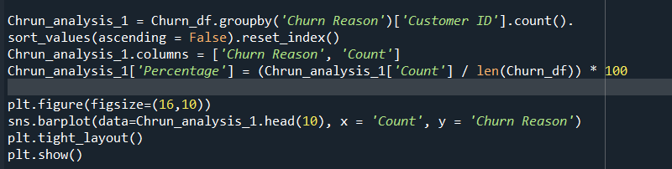

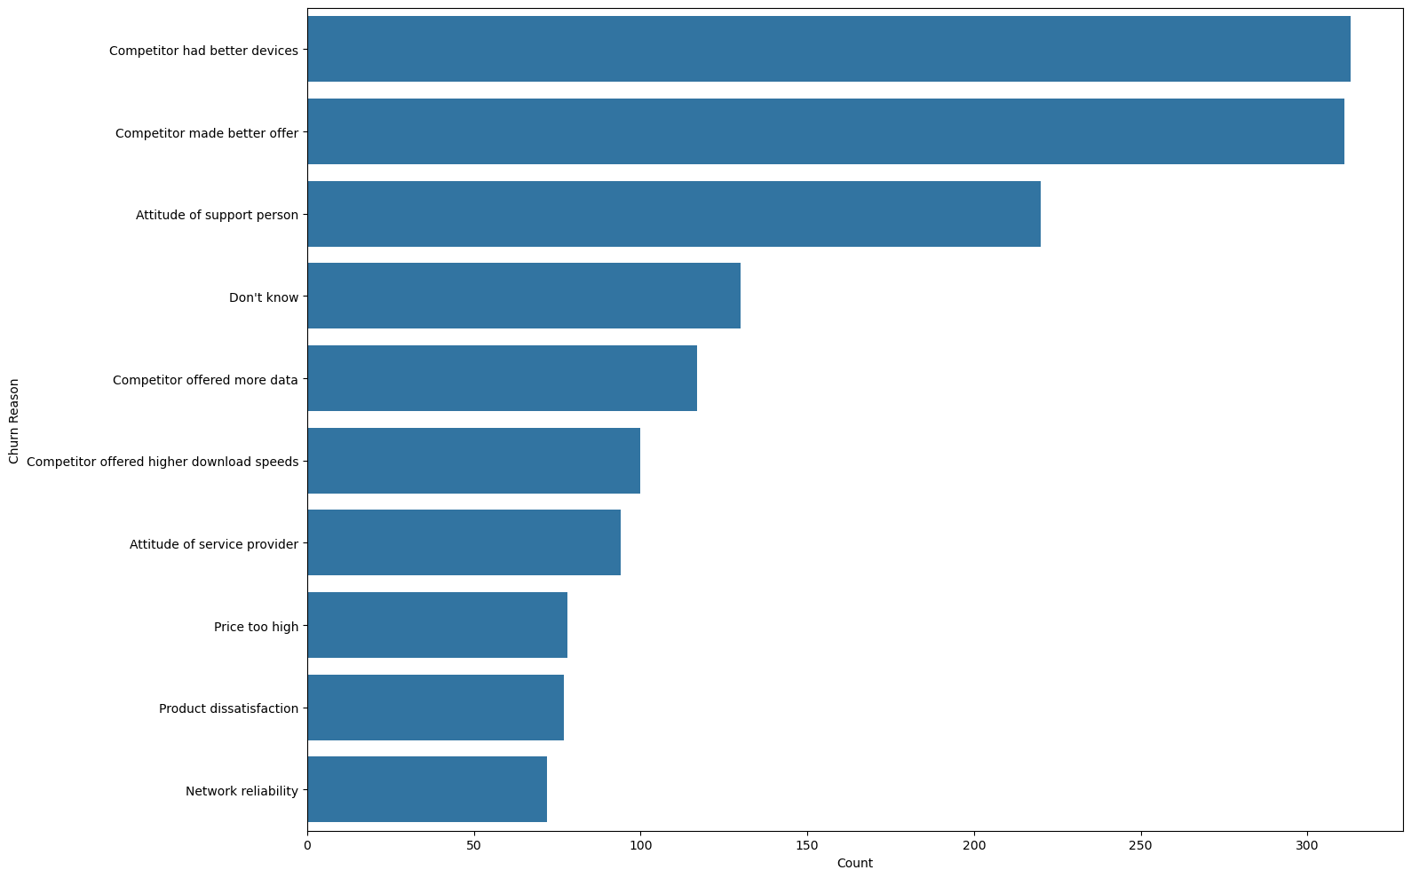

CONCLUSION
Based on the above analysis, customer churn is not random and its purely based on the below reason
- Senior customer retention
- Specific products related issues
- Competitor better service
We need to focus on above three to retain the customer and win the business

THANK YOU

